
Architecture Implementation Roadmap and Migration Plan
EA Blueprint
SGLines
Table of Contents
1 Costs, Benefits, Dependencies and Risks 3
2 Timelines, Milestones and Ownership 4
3 Architecture Implementation Roadmap and Migration Plan 5

Document Information
Project Name: | EA Blueprint for SGLines
Prepared By: |  | Document Version No: | 0.1
Title: | Architecture Implementation Roadmap and Migration Plan | Document Version Date:
Reviewed By: |  | Review Date: | 11/05/2014
Distribution List
From | Date | Phone/Fax/Email

To | Action* | Due Date | Phone/Fax/Email
* Action Types: Approve, Review, Inform, File, Action Required, Attend Meeting, Other (please specify)
Document Version History
Version  Number | Version  Date | Revised By | Description | Filename

Costs, Benefits, Dependencies and Risks
Of the indentified nine initiatives, we have derived the project list of nine and the respective implementation priority based on the risk and dependencies. We have also clustered the project list to three phases to the transition roadmap.
Project Initiatives | Category | Strategic Impact | Financial Impact | Risk | Opportunities for early success | Alignment with current initiatives | Resource Requirements | Dependency | Overall Priority Rank
1. SCBS | Business | H | H | H | L | M | H | M | H-3
2. VCMS | Business | H | H | H | M | M | H | M | H-2
3. Shipment Tracking (ShipTrack) | Business | H | M | M | M | L | H | M | H-4
4. ESB | Solution | M | L | M | M | L | L | H | H-1
5. MQ for HRS | Technical | L | L | L | H | H | L | M | L-8
6. MQ for AFIS | Technical | L | L | L | H | H | L | M | L-9
7. Interface Engine | Solution | M | L | M | H | L | M | H | M-5
8. Web Portal | Information | M | L | M | H | M | M | H | M-6
9. Management Reports | Information | M | M | M | H | M | M | M | M-7

Costing and Risk identification on each project:

1. SCBS
Sales order and customer billing system, this is a must-have requirement. As proposed to be a central system, with high degree of data integrity.
Major Costing:
Infrastructure:
Server: Windows Server 2012 Operating System (Blade Servers)
Cost: 20000 SGD (Investment for 5 Years)
Yearly Maintenance: Around 2000 SGD.
Internet: 2000 SGD (Investment for every year)
Application Development/Rollouts:
In-house Model
Database licensing:
Oracle: 35000 SGD (Standard) 11g
Resource:
Man Hours: 2880, 3 Months – (4 developers)
Cost: 100800 @ 35 SGD / Man Hr
Dependency:
ESB
Risk:
Compatible to the existing system integration.
Data migration.
Value & Benefits:
Reduce response time to customer queries.
Reduce time spending customer complaints.
Man power reduction. (Complaints Checks/Phone call to record the order)

Reduce 3 hr/day of man power, for 3 customer service representatives to record the purchase order over phone or by fax.
Saving, 64800 SGD per year @ 20 SGD man hr cost
2. VCMS
It is the central integrated system for the vessel and the container movement system. This is an operational system and categorized as a critical system and belongs to must-have requirement.

Major Costing:
Infrastructure:
Shares the infrastructure and maintenance cost for the server as of the technology architecture.
Application Development/Rollouts:
In-house Model
Database licensing:
Shares the investment cost for the database as of the central system defined by the technology architecture.
Resources:
Man Hours: 3840, 4 Months – (4 developers)
Cost: 134400 @ 35 SGD / Man Hr
Dependency:
ESB
Value & Benefits:
Reduce response time. (Time to market)
Man power reduction. (Manual Checks)
Improve quality.

Reduce 2 hr/day of man power, for 2 operations experts on checking the manual data verification.
Saving, 43200 SGD per year @ 30 SGD man hr cost

3. Shipment Tracking (ShipTrack)
It is a web implementation exposed to customers to track the shipping entity status. This is a must-have requirement.

Major Costing:
Infrastructure:
Shares the infrastructure and maintenance cost for the server as of the technology architecture.
Application Development/Rollouts:
In-house Model
Database licensing:
Shares the investment cost for the database as of the central system defined by the technology architecture.
Resources:
Man Hours: 960, 2 Months – (2 developers)
Cost: 33600 @ 35 SGD / Man Hr
Dependency:
VCMS (to track operations status) and SCBS (to track the delivery status)
Value & Benefits:
Reduce response time to customer queries.
Reduce time spending customer complaints.
Man power reduction. (Complaints and tracking the shipment status checks)

Reduce 1 hr/day of man power, for 2 customer representative to check the shipping status.
Saving, 14400 SGD per year @ 20 SGD man hr cost

4. ESB
We have proposed to implement as the open source, also enclosed a supportive result to make a decision.

Major Costing:
Infrastructure:
Shares the infrastructure and maintenance cost for the server as of the technology architecture.
Application Development/Rollouts:
Vendor selection: Plan is to consider the potential of an open source ESB and upgrade to more robust solutions as need arise. (MuleSoft)
In-house Model (Opportunities and Solutions)
Orchestrations of the applications for the integration are done as a part of the setting up the ESB. The further adding/removing the message registers is done as a part of the maintenance.
Resources:
Man Hours: 480, 1 Months – (2 developers)
Cost: 16800 @ 35 SGD / Man Hr

5. MQ for HRS/AFIS
These applications can be integrated using the MQ-Message Queuing, to the ESB for the enterprise integration. It is a nice to have requirement.

Major Costing:
Application Development/Rollouts:
In-house Model
Resources:
Man Hours: 480, 1 Months – (2 developers)
Cost: 16800 @ 35 SGD / Man Hr

6. Interface Engine, Management Reports and Web Portal
These are related to the primary interfaces for the major systems (VCMS, SCBS and Shipping tracking).

Major Costing:
Infrastructure:
Shares the infrastructure and maintenance cost for the server as of the technology architecture.
Application Development/Rollouts:
In-house Model
Database licensing:
Shares the investment cost for the database as of the central system defined by the technology architecture.
Resources:
Man Hours: 1920, throughout the transition (2 months & 4 developers)
Cost: 67200 @ 35 SGD / Man Hr
Dependency:
VCMS (to track operations status) and SCBS (to track the delivery status)
Value & Benefits:
Customer satisfaction and increase in customer retention.
Support B2B applications, using the Interface Engine. (Mass responses)
Benefit @40000~ 100000 per year.
 | Year 1 | Year 2 | Year 3 | Year 4 | Year 5
Capital Cost (Infrastructure) | 55000 | 0 | 0 | 0 | 0
Capital Cost (Development) | 369600 | 0 | 0 | 0 | 0
Yearly Maintenance Cost | 10000 | 10000 | 10000 | 10000 | 10000
Savings | 0 | 162400 | 182400 | 202400 | 222400
Expenses | 434600 | 282200 | 109800 | -82600 | -295000
ROI | 0 | 0 | 0 | 82600 | 295000

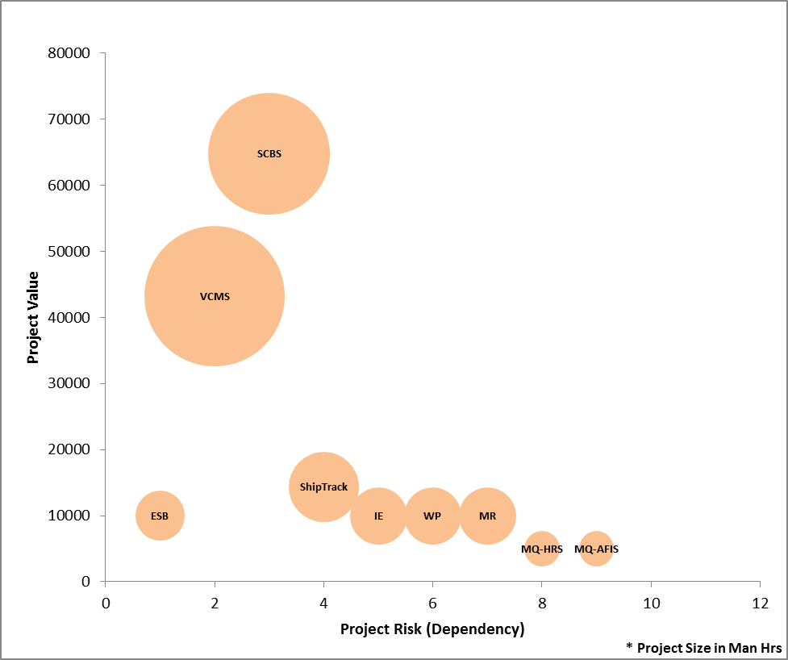
Project Bubble

Timelines, Milestones and Ownership

Phase 1: (1-6 Months)
The following are the project clusters that have higher dependency to go live together with good benefits in values for the first phase. This also facilitates the seamless integration capability with account to the decommissioning of existing system.
- ESB,
- VCMS, Data migration for VCMS, VCMS Compatibility support to existing systems,
- Management Reports,
- Interface Engine and
- Web portal.

Phase 2: (4-10 Months)
The following are the project clusters that have next higher dependency with less risk to the earlier phase; this also facilitates an enterprise level integration.
  - SCBS, Data migration for SCBS,
  - Shipment Tracking,
  - Management Reports,
  - Interface Engine and
  - Web portal.

Phase 3: (6-12 Months)
The less prioritized projects, moderate business values with low risk, follows the legacy systems that to integrate using ESB.
  - MQ implementation for HRS and AFIS,
  - Management Reports,
  - Interface Engine and
  - Web portal.

 | Projects | Ownership
Phase 1 | ESB | IT/Operations
Phase 1 | VCMS | Container Management Team
Phase 1 | IE | IT/Operations
Phase 1 | Web portal | Container Management Team
Phase 1 | Reports | Container Management Team
Phase 2 | SCBS | Order Processing Team
Phase 2 | ShipTrack | Order Processing Team
Phase 2 | IE | IT/Operations
Phase 2 | Web portal | Order Processing Team
Phase 2 | Reports | Order Processing Team
Phase 3 | MQ HRS | HR & Finance Team
Phase 3 | MQ AFIS | HR & Finance Team
Phase 3 | IE | IT/Operations
Phase 3 | Web portal | HR & Finance Team
Phase 3 | Reports | HR & Finance Team

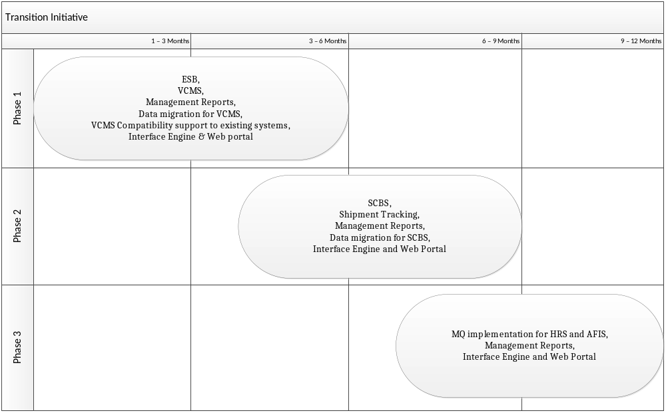

Architecture Implementation Roadmap and Migration Plan

Business Architecture by Phases:

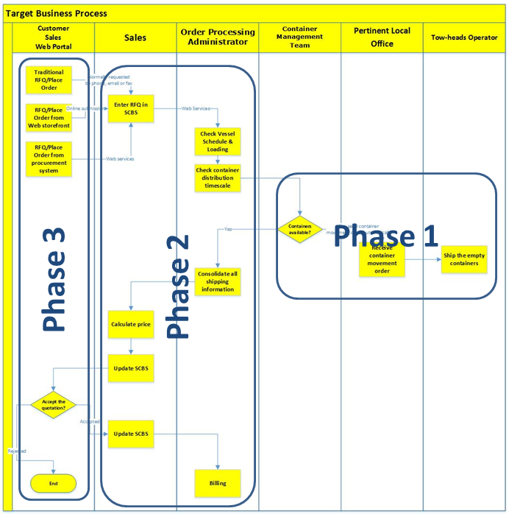

Application Architecture by Phases:

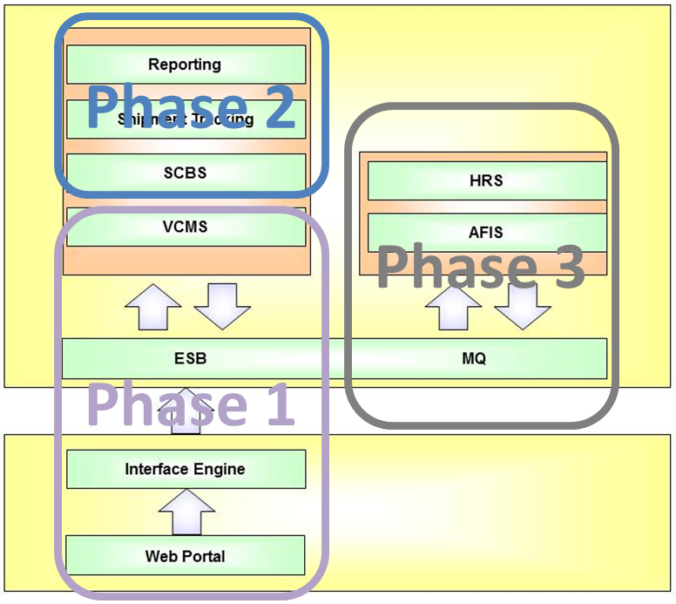

Information Architecture by Phases:

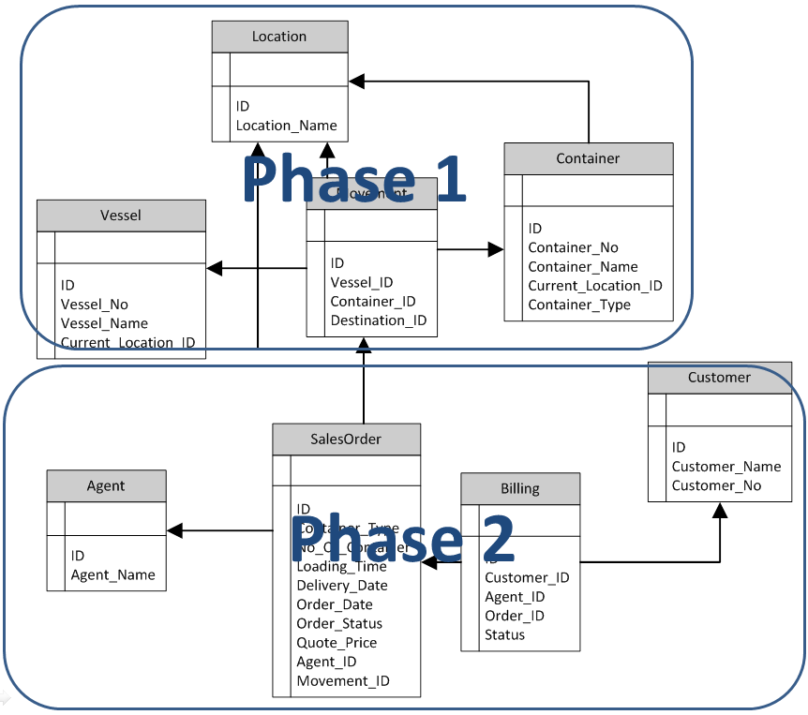

Technology Architecture by Phases:

